**Experiment No. 1.2**

**Student Name: Gaurav Kumar UID: 22MCC20177**

**Branch: MCA - CCD Section/Group: 22MCD1 / Grp A**

**Semester: II Date of Performance: 28th Feb 2023**

**Subject Name: AIP Lab Subject Code: 22CAP-686**

1. **Aim/Overview of the Practical**

Create a servlet that describes how to use the HttpSession object to find out the creation time and the last accessed time for a session. We would associate a new session with the request if one does not already exist.

1. **Task to be done**

To write a servlet code to use the HttpSession for finding out the creation & last accessed time for a session. If the session does not exist then it displays a successful session creation message else it shows the welcome back message.

1. **Algorithm/Steps**

* Edit the **.java** file which has the servlet code & modify the **processRequest** method.
* Use the java print statement to write the html code for creating a HttpSession object using the following code:
  + *HttpSession session= request.getSession(true);*
* Create a Table in html to display the ID, Creation time & accessed time in a proper format.

1. **Code for the Practical**

**------------------ Method “processRequest” Java Code ------------------**

protected void processRequest(HttpServletRequest request, HttpServletResponse response)

throws ServletException, IOException {

response.setContentType("text/html;charset=UTF-8");

try (PrintWriter out = response.getWriter()) {

/* TODO output your page here. You may use following sample code. */

out.println("<!DOCTYPE html><html><head>");

out.println("<title>Servlet amarp</title>");

out.println("</head><body>");

HttpSession session= request.getSession(true);

if(session.isNew()) {

out.println("new user");

} else{

out.println("welcome back");

}

out.println("<table border=1 align=center>\n");

out.println("<th> info <th> value\n");

out.println("<tr>\n");

out.println("<td> ID<td>" + session.getId() + "\n");

out.println("<tr>\n");

out.println("<td> Creation Time<td>" + new Date(session.getCreationTime()) + "\n");

out.println("<tr>\n");

out.println("<td> Accessed Time<td>" + new Date(session.getLastAccessedTime()) + "\n");

out.println("</tr><table>");

out.println("<h1>Servlet amarp at " + request.getContextPath() + "</h1>");

out.println("</body></html>");

}

}

1. **Result/Output/Writing Summary**

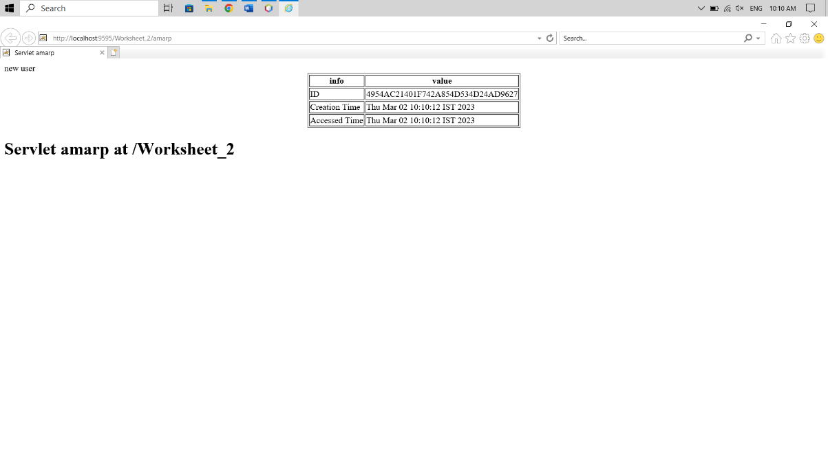

1. **Learning Outcomes (What I have learned)**
2. Learned to create a servlet that uses HttpSession object.
3. Learned to access the already existing session or create a new one.